Answers to Lab: Knative on Kubernetes (Windows + Minikube)
1. Introduction
This lab provides hands-on experience with Knative, a Kubernetes-based platform for building, deploying, and managing serverless cloud-native applications. The experiment was conducted on Windows 11, using Docker Desktop as the container runtime and Minikube as the local Kubernetes cluster.
The objectives of this lab are:
- To install and configure Knative Serving
- To deploy a simple Knative Service
- To install and configure Knative Eventing
- To create and validate a Broker-based eventing workflow
- To understand and resolve common deployment issues in restricted or local environments
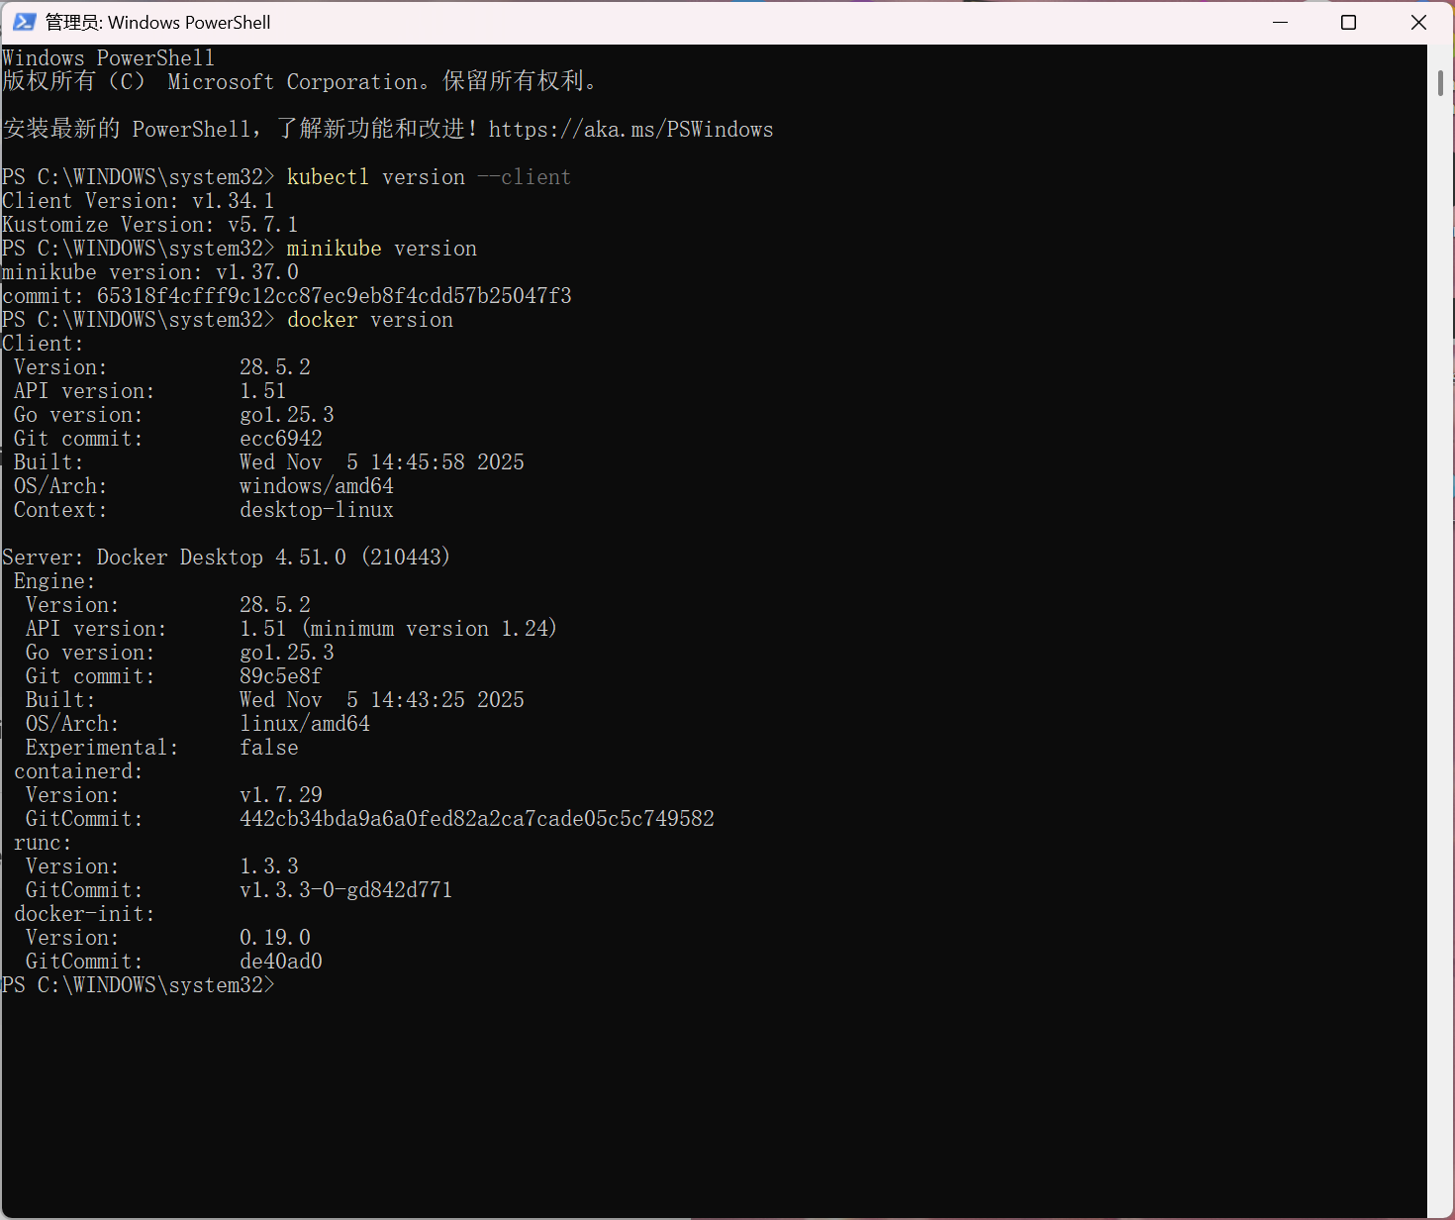
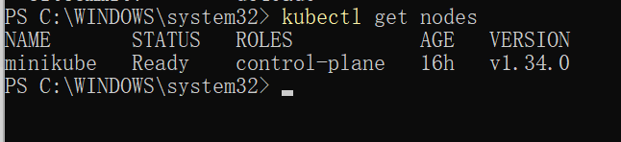
2. Experimental Environment
- Operating System: Windows 11
- Container Runtime: Docker Desktop (Kubernetes enabled)
- Kubernetes Cluster: Minikube v1.37.0 (Docker driver)
- Knative Components:
  - Knative Serving
  - Knative Eventing
  - Kourier (Networking Layer)
  - InMemoryChannel (Eventing Channel)

3. Knative Serving Installation
3.1 Installing Knative Serving CRDs and Core Components
Due to network access issues when applying remote YAML files directly, the required Knative Serving manifests were downloaded manually and applied from the local filesystem.
kubectl apply -f C:\knative\serving\serving-crds.yaml
kubectl apply -f C:\knative\serving\serving-core.yaml
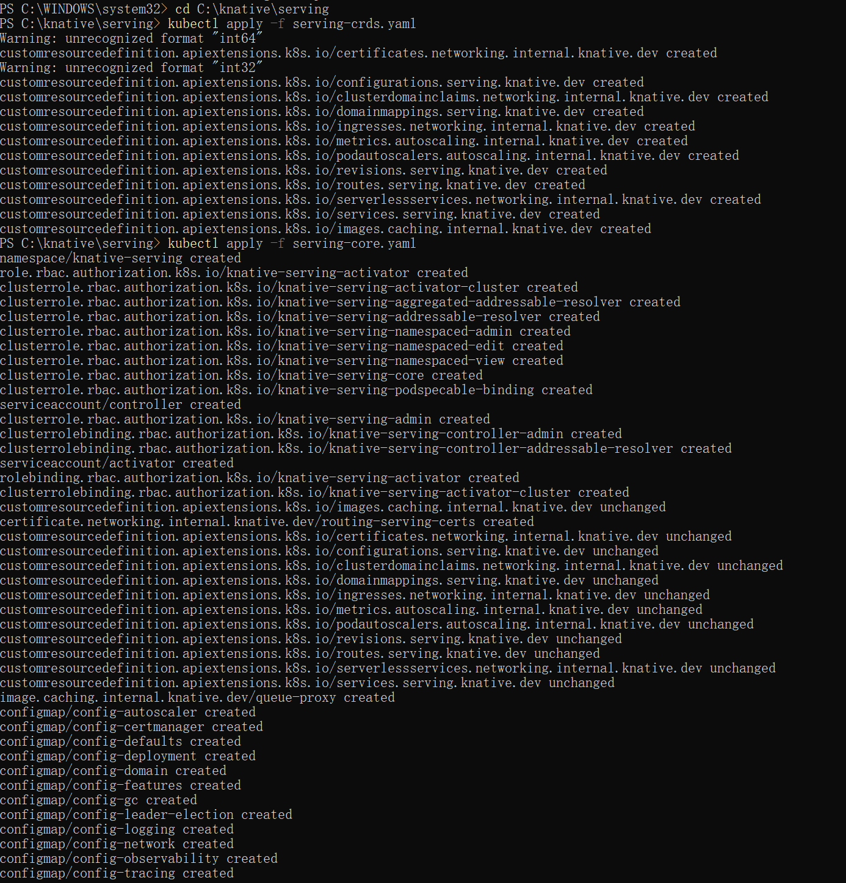
3.2 Verifying Knative Serving Pods
kubectl get pods -n knative-serving
Initially, all pods were stuck in the ContainerCreating state.
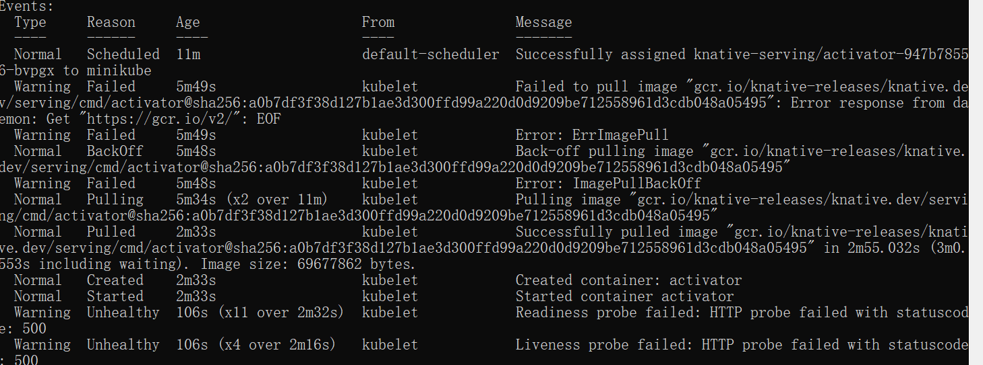

3.3 Resolving Image Pull Issues (Manual Docker Pull)
Inspection of pod YAML revealed that the images were hosted on gcr.io, which caused pull delays.
kubectl get pods -n knative-serving -o yaml | Select-String image
All required images were manually pulled using Docker:
docker pull gcr.io/knative-releases/knative.dev/serving/cmd/activator
docker pull gcr.io/knative-releases/knative.dev/serving/cmd/autoscaler
docker pull gcr.io/knative-releases/knative.dev/serving/cmd/controller
docker pull gcr.io/knative-releases/knative.dev/serving/cmd/webhook
After pulling the images, all pods transitioned to Running.
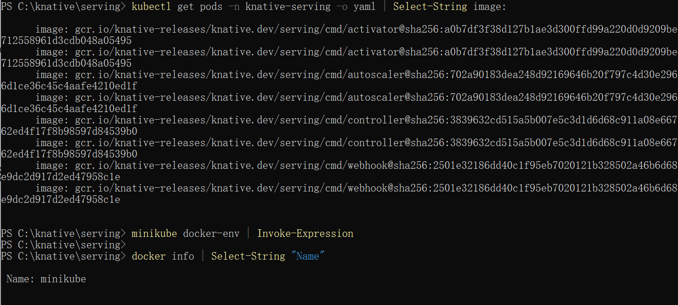
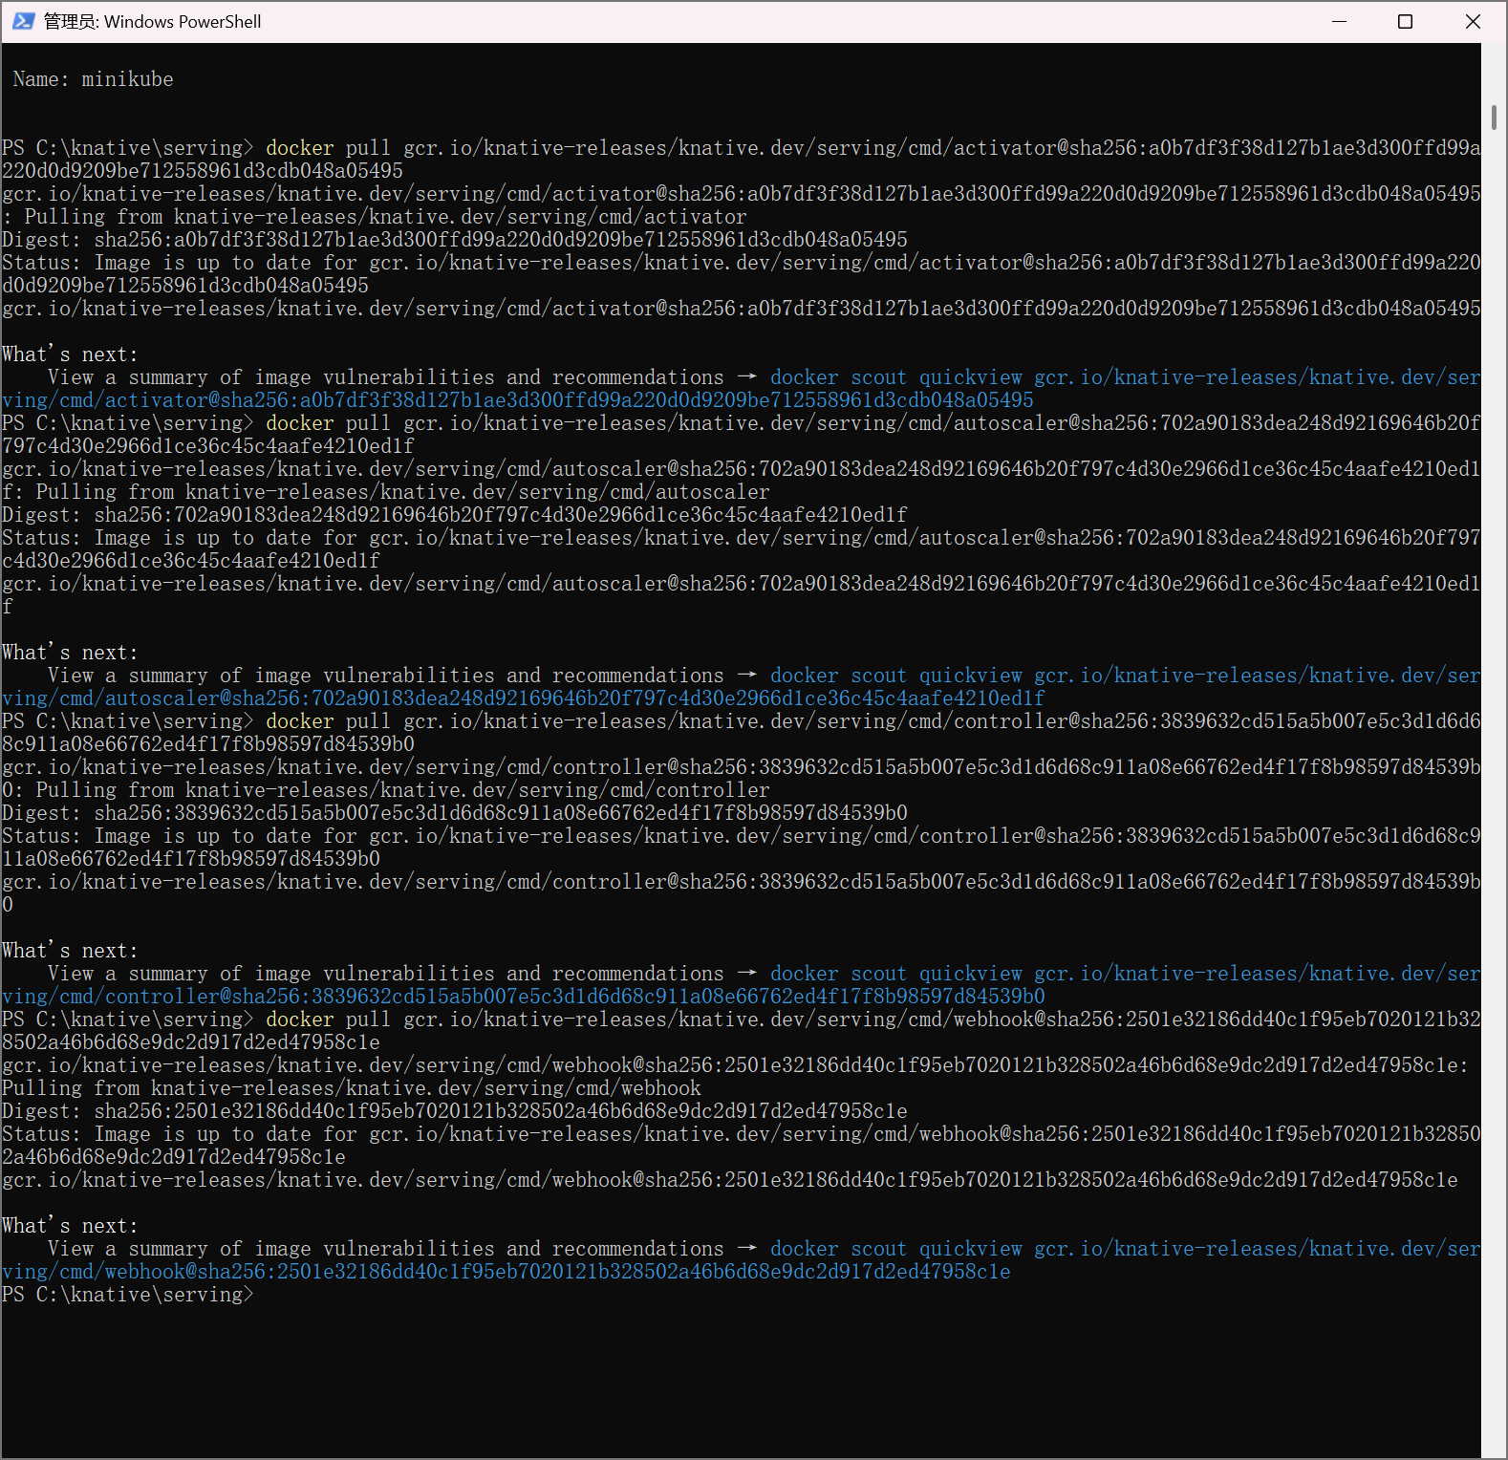
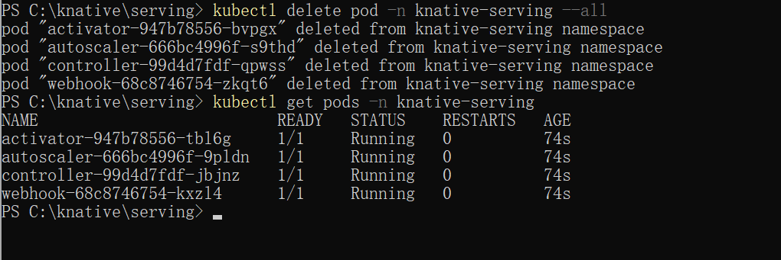
4. Installing Kourier Networking Layer
Kourier was used as the networking layer for Knative Serving.
kubectl apply -f C:\knative\networking\kourier.yaml
After resolving a similar image pull issue with Envoy, the Kourier gateway became ready.
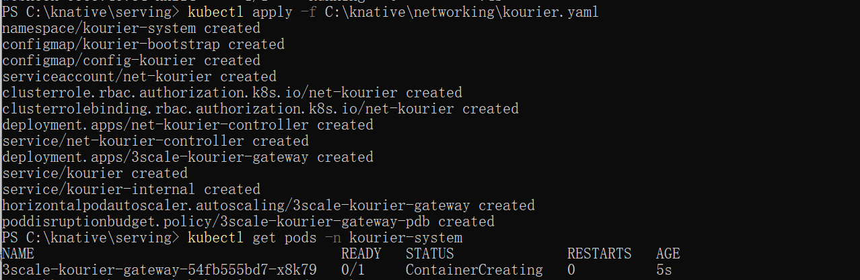
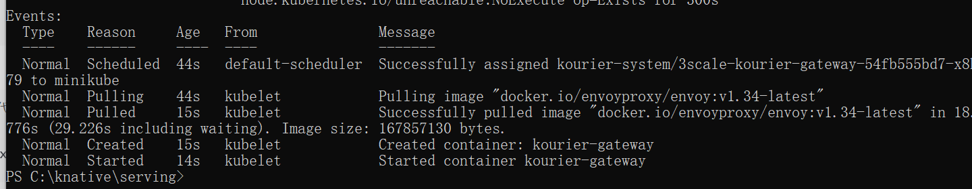
5. Deploying a Knative Service
A simple Knative Service (hello) was deployed using a YAML manifest.
kubectl apply -f hello-knative.yaml
kubectl get ksvc
Initially, the service showed RevisionMissing, which was resolved after ensuring the container image was available locally.
docker pull gcr.io/knative-samples/helloworld-go
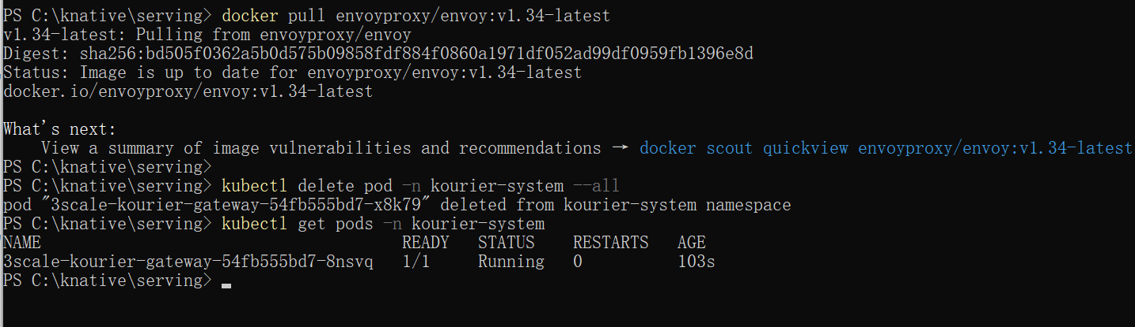
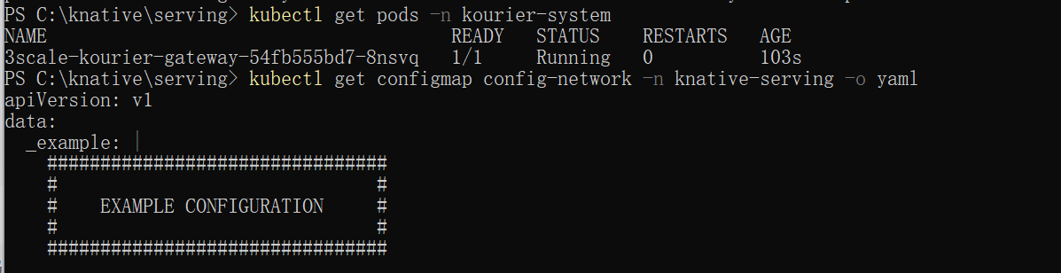
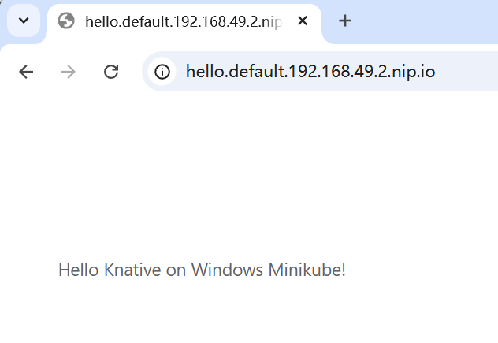

6. Knative Eventing Installation
6.1 Installing Eventing CRDs and Core
kubectl apply -f C:\knative\eventing\eventing-crds.yaml
kubectl apply -f C:\knative\eventing\eventing-core.yaml
kubectl get pods -n knative-eventing
Similar to Serving, one pod (eventing-webhook) initially remained in ContainerCreating state.
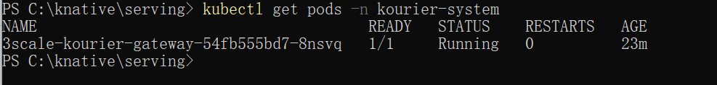
6.2 Resolving Eventing Image Pull Issue
The image used by eventing-webhook was identified and manually pulled:
kubectl get pod eventing-webhook -n knative-eventing -o yaml | Select-String image
docker pull gcr.io/knative-releases/knative.dev/eventing/cmd/webhook
After this step, all Eventing pods were running.
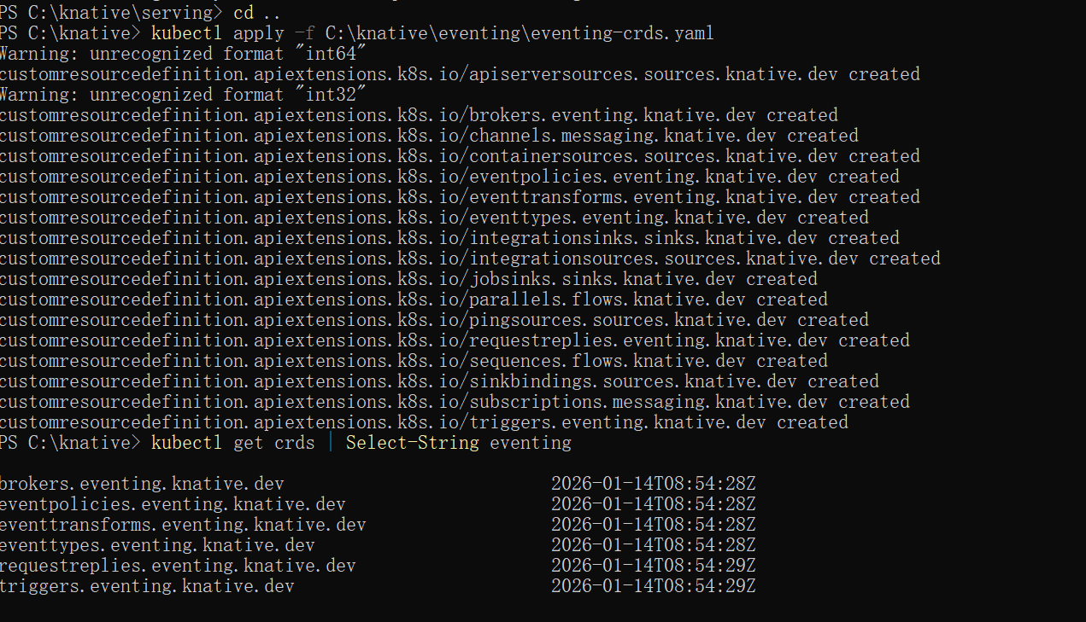
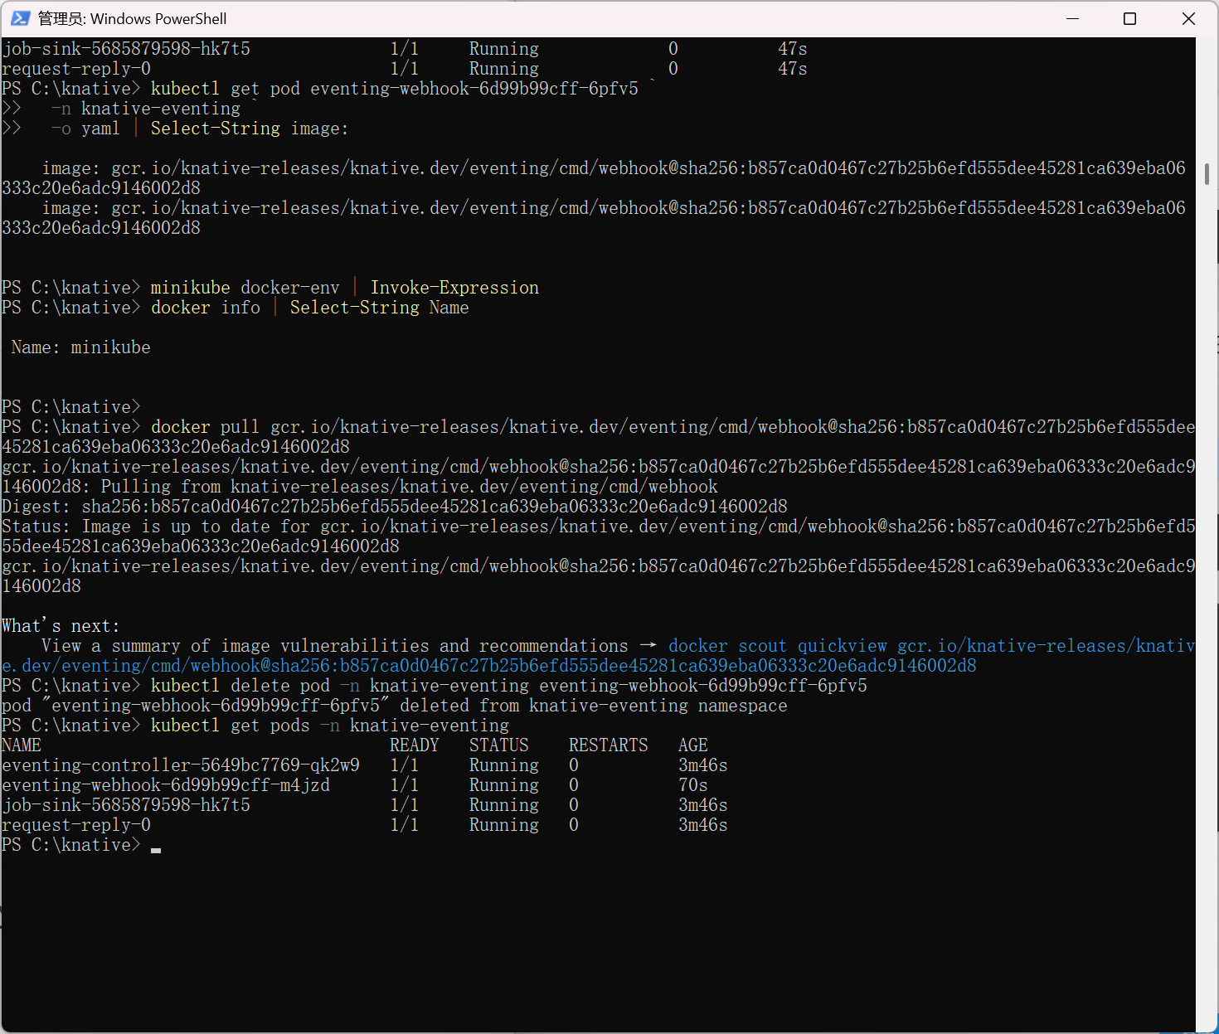
7. Creating a Default Broker
A default Broker was created in the default namespace.
kubectl get broker
kubectl describe broker default
At this stage, the Broker existed but remained Not Ready.

8. Debugging Broker Not Ready Issue
8.1 Observed Error
The Broker status showed:
READY: False
REASON: ChannelTemplateFailed
This indicated that no default Channel implementation was available.

8.2 Root Cause Analysis
Knative Eventing’s MT Channel Based Broker requires a messaging backend (Channel).
By default, no Channel is installed automatically.

8.3 Solution: Installing InMemoryChannel
The InMemoryChannel was installed as the default Channel implementation.
kubectl apply -f C:\knative\eventing\in-memory-channel.yaml
kubectl get pods -n knative-eventing
After the Channel controller and dispatcher became ready, the Broker automatically transitioned to Ready.
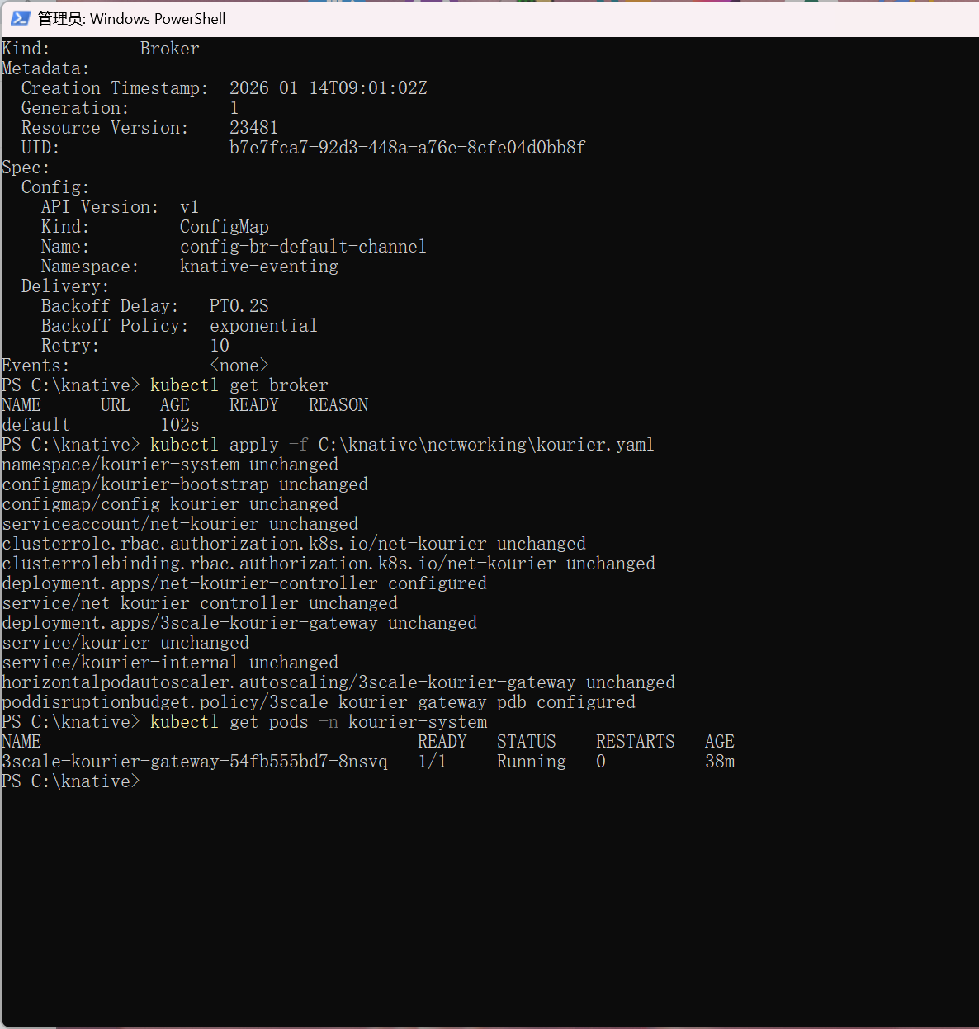
9. Final Verification
kubectl get broker
Final output:
NAME READY URL
default True http://broker-ingress.knative-eventing.svc.cluster.local
This confirms that Knative Eventing is fully functional.
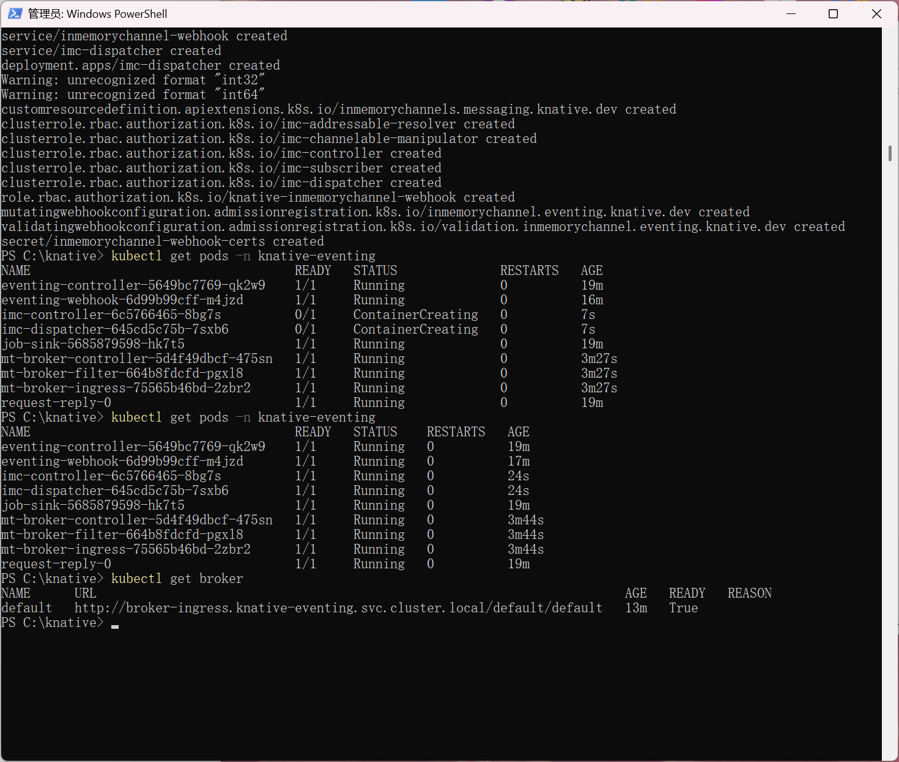
10. Conclusion
In this lab, Knative Serving and Eventing were successfully deployed on a local Kubernetes cluster using Minikube on Windows. Several real-world issues were encountered, including image pull failures and missing Channel implementations. By systematically inspecting pod states, identifying root causes, and applying targeted fixes, all issues were resolved.
This experiment demonstrates not only the usage of Knative but also essential debugging and operational skills required for managing cloud-native systems in constrained or local environments.

11. Repository Structure Recommendation
knative-lab/
├── README.md
├── screenshots/
│ ├── serving-install.png
│ ├── serving-running.png
│ ├── kourier-running.png
│ ├── ksvc-running.png
│ ├── eventing-running.png
│ ├── broker-not-ready.png
│ └── broker-ready.png
